PART I DATA

1 The Production

Company Charleroi Danses
Show Neige
Director Michèle Anne de Mey
Set designer Sylvie Olive
Lighting designer Nicolas Olivier

Sound designer
Costume designer
Producer Van Baasbank & Baggerman
Date
Theatre

2 The Theatre

Name of the theatre
Address
Postal code & city
General phone number
General fax number
General e-mail address
Technical phone number

Technical fax number
Technical e-mail address

Contacts:
General management
Technical management
General RAI responsible
RAI responsible on stage

3 The Company

Name of the company Charleroi Danses
Address Boulevard Mayence 65 C
Postal code & city B-6000 CHARLEROI
Country of residence Belgium
General phone number +32- 071-20 56 40
General fax number +32- 071-20 56 49
General e-mail address info@charleroi-danses.be
Technical phone number 00 32 71 50 92 82
Technical fax number
technical e-mail address technique@charleroi-danses.be
Mobile phone on tour 00 32 475 69 27 36
Contacts:
General management
Technical management Gianni Brecco
Production management Ludovicca Riccardi
Stage manager on tour Nicolas Olivier
Rigging engineer on tour
Lighting engineer on tour Nicolas Olivier
Sound engineer on tour
General RAI responsible Gianni Brecco
RAI responsible on tour Nicolas Olivier

4 The Producer

Name of the producer Van Baasbank & Baggerman
Address Keizersgracht 258
Postal code & city 1016 EV Amsterdam
General phone number 020-6242631
General fax number 020-6227850
General e-mail address info@baasbank-baggerman.nl
Technical phone number 06-50267679
Technical fax number 030-2948401
Technical e-mail address marijcke@baasbank-baggerman.nl
Contacts:
General management Jaap van Baasbank
Production management JG Baggerman
Technical management Marijcke Voorsluijs
Stage manager on tour Willem Scheepstra
General RAI responsible Marijcke Voorsluijs
RAI responsible on tour Willem Scheepstra

PART II RESPONSIBILITIES

1 The Theatre
- Knowledge of risk assessment and safety regulations, shown in a general Risk Assessment Inventory (in Dutch: RI&E).
- Practise of this knowledge at the workplace.
- Responsible behaviour of technicians employed or hired by the theatre.
- Safety education of technicians employed or hired by the theatre.
- Appropriate personal protective equipment for technicians employed by the theatre.
- Safety on stage in general.
- Safety, certification and maintenance of house materials and utensils.
- Safe operation of the theatre's installations.
- Safety of materials rented by the theatre.
- Contact with local fire department to obtain permits for fire effects, based on information provided by the company through the producer.
- Working schedule for technicians employed or hired by the theatre, based on agreements between company and theatre, in accordance with the Dutch working hours regulations.

2 The Company
- Knowledge of risk assessment and safety regulations valid in the Netherlands.
- Practise of this knowledge at the workplace.
- Responsible behaviour of technicians employed or hired by the company.
- Safety education of technicians employed or hired by the company.
- Correct, appropriate and complete information about the safety aspects of the production for the producer and the theatre.
- Appropriate safety instructions for house technicians about the company's materials, during setup, rehearsal, show and strike
- Appropriate personal protective equipment for company technicians, and for house technicians if necessary for handling company materials or installations.
- Safety, certification and maintenance of all company materials and utensils used on tour.
- Safe operation of company installations.
- Safety of materials rented by the company.
- Working schedule for technicians employed or hired by the company in accordance with the Dutch working hours regulations.

3 The Producer
- Knowledge of risk assessment and safety regulations valid in the Netherlands.
- Practise of this knowledge at the workplace.
- Correct, appropriate and complete information about the standards, rules and regulations in the Netherlands.
- Correct, appropriate and complete information about the safety aspects of the production to the theatre, based on information provided by the company.
- Work permits for company members.
- Adequate tour planning as to enable the company to schedule its members in accordance with the Dutch working hours regulations.
- Responsible behaviour of technicians employed or hired by the producer.
- Safety education of technicians employed or hired by the producer.
- Appropriate personal protective equipment for technicians employed by the producer.
- Safety of materials owned or rented by the producer.
- Working schedule for technicians employed or hired by the producer in accordance with the Dutch working hours regulations.

Has a person been designated to be responsible for safety on stage from setup till strike?
Is personal protective equipment being provided and used? technicians wear safety shoes
Is safety for the artists being taken into account with relation to:
- hazardous surfaces (sharp edges, corners, points, rough surfaces, protruding parts)? foam under dance floor, blue lights backstage
- movements of parts or material which may result in a person being hit? dancers are offstage when set moves
- trapping, tripping, falling and slipping? cables are taped
Is safety information being given to the audience about specific risks or hazards? no specific risks for the audience
Is working at heights avoided during setup and strike? focusing of lights
Is the set made of flame resistant material, or treated with flame retarder? set is fire resistant, including snow
Has the use of heavy materials been avoided? (specify weight of heaviest parts in last column) ordinary truss parts
Has overhead rigging of the set been avoided? screens, snow machines
Are the necessary certificates being carried? certified truss material
Are the persons who do the overhead rigging qualified to do so? (specify qualification) experienced theatre rigger
Are the costumes flame resistant, or treated with flame retarder? (Only in case of open fire.) no open fire
Does rental lighting equipment come from a professional company? (specify in last column) Flashlight
Has the use of smoke been avoided? smoke and dry ice
Are the persons who perform the special effects qualified to do so? (specify qualification) instructions for handling dry ice are obeyed, dry ice handled only by the responsible person from the company

Are wheels or other utensils being used to reduce lifting and carrying of weight by persons? set moves on rail
Is pushing and pulling of heavy weights being avoided? we need 6 people from the theatre during the show to safely perform the set movements!
Are all participants clearly informed about their job and their responsibility? movements are explained and practised on the day of the show

PART IV SIGNATURES
The theatre declares
- to accept the responsibilities described in part II of this document
- to have read and accepted the information given in part I and III

The company declares
- to accept the responsibilities described in part II of this document
- to have given complete and correct information in part I and III is
- that the information is given by persons with ample knowledge of safety and risk assessment at the workplace.

The producer declares
- to accept the responsibilities described in part II of this document
- to have read and accepted the information given in part I and III

The theatre The company The producer
Name Name Nicolas Olivier for Gianni Brecco Name Marijcke Voorsluijs
Date Date 26 januari 2010 Date 26 januari 2010
Signature Signature Signature
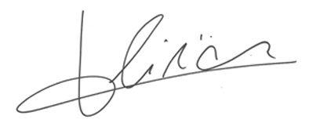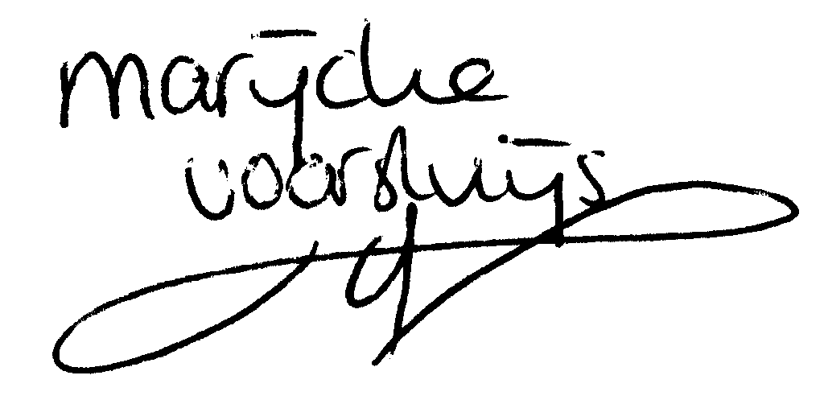

© Marijcke Voorsluijs for Van Baasbank & Baggerman (Thanks to Stadsschouwburg Utrecht and Het Muziektheater), June 2002
Reproduction and use of this document is authorized, provided the source is acknowledged and the writer informed
Comments are always greatly appreciated! Please send an e-mail to marijcke@totheater.nl

