PART I DATA

1 The Production

Company Raw Dance Company
Show Bang! Crash! Tap!
Director Andrew Fee
Set designer n/a
Lighting designer Troy Kelly

Sound designer N/A
Costume designer N/A
Producer Van Baasbank & Baggerman
Date
Theatre

2 The Theatre

Name of the theatre
Address
Postal code & city
General phone number
General fax number
General e-mail address
Technical phone number

Technical fax number
Technical e-mail address

Contacts:
General management
Technical management
General RAI responsible
RAI responsible on stage

3 The Company

Name of the company Raw Dance Company
Address 46 Evesham Street
Postal code & city Moorooka QLD 4105
Country of residence Australia
General phone number +61 7 3122 0941
General fax number n/a
General e-mail address admin@raw.ws
Technical phone number +61 (0) 7 3122 0941
Technical fax number n/a
technical e-mail address troy@raw.ws
Mobile phone on tour +61-414418239
Contacts:
General management Andrew Fee
Technical management Troy Kelly
Production management Troy Kelly
Stage manager on tour Troy Kelly
Rigging engineer on tour Troy Kelly
Lighting engineer on tour Troy Kelly
Sound engineer on tour Seb Jongejans
General RAI responsible Troy Kelly
RAI responsible on tour Troy Kelly

4 The Producer

Name of the producer Van Baasbank & Co
Address Keizersgracht 258
Postal code & city 1016 EV Amsterdam
General phone number 020-6242631
General fax number 020-6227850
General e-mail address info@baasbank-co.nl
Technical phone number 06-50267679
Technical fax number 020-6227850
Technical e-mail address marijcke@baasbank-co.nl
Contacts:
General management Jaap van Baasbank
Production management Dick Vos
Technical management Marijcke Voorsluijs
Stage manager on tour Seb Jongejans
General RAI responsible Marijcke Voorsluijs
RAI responsible on tour Seb Jongejans

PART II RESPONSIBILITIES

1 The Theatre
- Knowledge of risk assessment and safety regulations, shown in a general Risk Assessment Inventory (in Dutch: RI&E).
- Practise of this knowledge at the workplace.
- Responsible behaviour of technicians employed or hired by the theatre.
- Safety education of technicians employed or hired by the theatre.
- Appropriate personal protective equipment for technicians employed by the theatre.
- Safety on stage in general.
- Safety, certification and maintenance of house materials and utensils.
- Safe operation of the theatre's installations.
- Safety of materials rented by the theatre.
- Contact with local fire department to obtain permits for fire effects, based on information provided by the company through the producer.
- Working schedule for technicians employed or hired by the theatre, based on agreements between company and theatre, in accordance with the Dutch working hours regulations.

2 The Company
- Knowledge of risk assessment and safety regulations valid in the Netherlands.
- Practise of this knowledge at the workplace.
- Responsible behaviour of technicians employed or hired by the company.
- Safety education of technicians employed or hired by the company.
- Correct, appropriate and complete information about the safety aspects of the production for the producer and the theatre.
- Appropriate safety instructions for house technicians about the company's materials, during setup, rehearsal, show and strike
- Appropriate personal protective equipment for company technicians, and for house technicians if necessary for handling company materials or installations.
- Safety, certification and maintenance of all company materials and utensils used on tour.
- Safe operation of company installations.
- Safety of materials rented by the company.
- Working schedule for technicians employed or hired by the company in accordance with the Dutch working hours regulations.

3 The Producer
- Knowledge of risk assessment and safety regulations valid in the Netherlands.
- Practise of this knowledge at the workplace.
- Correct, appropriate and complete information about the standards, rules and regulations in the Netherlands.
- Correct, appropriate and complete information about the safety aspects of the production to the theatre, based on information provided by the company.
- Work permits for company members.
- Adequate tour planning as to enable the company to schedule its members in accordance with the Dutch working hours regulations.
- Responsible behaviour of technicians employed or hired by the producer.
- Safety education of technicians employed or hired by the producer.
- Appropriate personal protective equipment for technicians employed by the producer.
- Safety of materials owned or rented by the producer.
- Working schedule for technicians employed or hired by the producer in accordance with the Dutch working hours regulations.

PART III CHECKLIST
Does the company carry an appropriate First Aid Kit for those who work on stage?
Is safety for the artists being taken into account with relation to:
- hazardous surfaces (sharp edges, corners, points, rough surfaces, protruding parts)? artists are used to jump up&down rostra
Is safety for the audience being taken into account with relation to:
- trapping, tripping, falling and slipping? no objects installed in audience area
- blinding or electrocution of persons? no strong lights point at audience
Is safety information being given to the audience about specific risks or hazards? no specific risks for the audience
Is working at heights avoided during setup and strike? hanging of lights
Is a safe way to reach the working height being guaranteed? genie from the theatre
Are the persons who work at heights qualified to do so? (specify qualification) theatre technicians
Has the set been constructed by qualified persons? (specify in last column) rostra from the theatre
Is the set made of flame resistant material, or treated with flame retarder? backdrop is flame resistant
Are certificates being carried?
Are the costumes flame resistant, or treated with flame retarder? (Only in case of open fire.) no open flame
Does rental lighting equipment come from a professional company? (specify in last column) no lighting rentals
Does sound equipment brought by the company meet international safety standards?
Are regular checks being performed?
Does rental sound equipment come from a professional company? (specify in last column) no sound rentals

PART IV SIGNATURES
The theatre declares
- to accept the responsibilities described in part II of this document
- to have read and accepted the information given in part I and III

The company declares
- to accept the responsibilities described in part II of this document
- to have given complete and correct information in part I and III is
- that the information is given by persons with ample knowledge of safety and risk assessment at the workplace.

The producer declares
- to accept the responsibilities described in part II of this document
- to have read and accepted the information given in part I and III

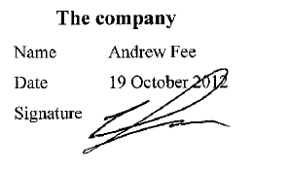
The theatre The company The producer
Name Name Andrew Fee Name Marijcke Voorsluijs
Date Date 19 October 2012 Date 12 oktober 2012
Signature Signature Signature
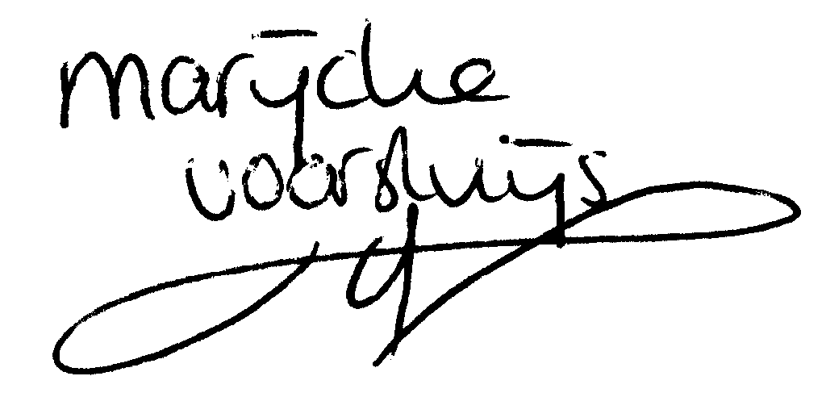
© Marijcke Voorsluijs for Van Baasbank & Baggerman (Thanks to Stadsschouwburg Utrecht and Het Muziektheater), June 2002
Reproduction and use of this document is authorized, provided the source is acknowledged and the writer informed
Comments are always greatly appreciated! Please send an e-mail to marijcke@totheater.nl

