PART I DATA

1 The Production

Company L¬E¬V
Show House
Director Sharon Eyal and Gai Behar
Set designer Avi Yona (Bambi) Bueno
Lighting designer Avi Yona (Bambi) Bueno
Sound designer Ori Lichtik
Costume designer Maayan Goldman
Producer Van Baasbank & Vos
Date
Theatre

2 The Theatre

Name of the theatre
Address
Postal code & city
General phone number
General e-mail address
Technical phone number
Technical e-mail address
Contacts:
General management
Technical management
General RAI responsible
RAI responsible on stage

3 The Company

Name of the company L¬E¬V
Address 35 Yehudit Ave.
Postal code & city Tel Aviv
Country of residence Israel
General phone number +972-54-5435173
General e-mail address info.levdance@gmail.com
Technical phone number +972 54-458-2542
technical e-mail address cohalon@gmail.com
Mobile phone on tour +972-8664452

Contacts:
General management Keren Gdalyhau Malki
Technical management Alon Cohen
Production management Keren Gdlyhau Malki
Stage manager on tour Alon Cohen
Rigging engineer on tour n/a
Lighting engineer on tour Alon Cohen
Sound engineer on tour Alon Cohen
General RAI responsible Gai Behar
RAI responsible on tour Alon Cohen

4 The Producer

Name of the producer Van Baasbank & Vos
Address Keizersgracht 258
Postal code & city 1016 EV Amsterdam
General phone number +31-20-6242631
General e-mail address info@baasbank-vos.nl
Technical phone number +31-650267679
Technical e-mail address marijcke@totheater.nl
Contacts:
General management Dick Vos
Production management Cherisa Katabaloeboeng
Technical management Marijcke Voorsluijs
Stage manager on tour Richard Bron
General RAI responsible Marijcke Voorsluijs
RAI responsible on tour Richard Bron

PART II RESPONSIBILITIES

1 The Theatre
- Knowledge of risk assessment and safety regulations, shown in a general Risk Assessment Inventory (in Dutch: RI&E).
- Practise of this knowledge at the workplace.
- Responsible behaviour of technicians employed or hired by the theatre.
- Safety education of technicians employed or hired by the theatre.
- Appropriate personal protective equipment for technicians employed by the theatre.
- Safety on stage in general.
- Safety, certification and maintenance of house materials and utensils.
- Safe operation of the theatre's installations.
- Safety of materials rented by the theatre.
- Contact with local fire department to obtain permits for fire effects, based on information provided by the company through the producer.
- Working schedule for technicians employed or hired by the theatre, based on agreements between company and theatre, in accordance with the Dutch working hours regulations.

2 The Company
- Knowledge of risk assessment and safety regulations valid in the Netherlands.
- Practise of this knowledge at the workplace.
- Responsible behaviour of technicians employed or hired by the company.
- Safety education of technicians employed or hired by the company.
- Correct, appropriate and complete information about the safety aspects of the production for the producer and the theatre.
- Appropriate safety instructions for house technicians about the company's materials, during setup, rehearsal, show and strike
- Appropriate personal protective equipment for company technicians, and for house technicians if necessary for handling company materials or installations.
- Safety, certification and maintenance of all company materials and utensils used on tour.
- Safe operation of company installations.
- Safety of materials rented by the company.
- Working schedule for technicians employed or hired by the company in accordance with the Dutch working hours regulations.

3 The Producer
- Knowledge of risk assessment and safety regulations valid in the Netherlands.
- Practise of this knowledge at the workplace.
- Correct, appropriate and complete information about the standards, rules and regulations in the Netherlands.
- Correct, appropriate and complete information about the safety aspects of the production to the theatre, based on information provided by the company.
- Work permits for company members.
- Adequate tour planning as to enable the company to schedule its members in accordance with the Dutch working hours regulations.
- Responsible behaviour of technicians employed or hired by the producer.
- Safety education of technicians employed or hired by the producer.
- Appropriate personal protective equipment for technicians employed by the producer.
- Safety of materials owned or rented by the producer.
- Working schedule for technicians employed or hired by the producer in accordance with the Dutch working hours regulations.

PART III CHECKLIST
Has a person been designated to be responsible for safety on stage from setup till strike? Alon Cohen
Is safety for the technicians being monitored with relation to:
- hazardous surfaces (sharp edges, corners, points, rough surfaces, protruding parts)? no set
- blinding or electrocution of persons? no such material
- fire or explosion? no such material
Is personal protective equipment being provided and used? technicans wear safety shoes
Is safety for the artists being taken into account with relation to:
- hazardous surfaces (sharp edges, corners, points, rough surfaces, protruding parts)? booms are marked
- movements of parts or material which may result in a person being hit? no movements
- trapping, tripping, falling and slipping? cables are taped
Is safety for the audience being taken into account with relation to:
- movements of parts or material which may result in a person being hit? no objects placed in the house
Is safety information being given to the audience about specific risks or hazards? no specific risks for the audience
Is working at heights avoided during setup and strike? only focusing lights
Is a safe way to reach the working height being guaranteed? genie from the theatre
Are the persons who work at heights qualified to do so? (specify qualification) theatre technicians
Are the props made of flame retardant material, or treated with flame retarder? no props
Is the safety of orchestra members in the pit being taken into account? we don't use the pit
Are the costumes flame resistant, or treated with flame retarder? (Only in case of open fire.) no open fire
Does rental lighting equipment come from a professional company? (specify in last column) Ampco Flashlight
Does sound equipment brought by the company meet international safety standards? no such equipment
Does rental sound equipment come from a professional company? (specify in last column) no such equipment
Has the use of smoke been avoided? rented hazer
Are wheels or other utensils being used to reduce lifting and carrying of weight by persons? lighting carts on wheels

PART IV SIGNATURES
The theatre declares
- to accept the responsibilities described in part II of this document
- to have read and accepted the information given in part I and III

The company declares
- to accept the responsibilities described in part II of this document
- to have given complete and correct information in part I and III is
- that the information is given by persons with ample knowledge of safety and risk assessment at the workplace.

The producer declares
- to accept the responsibilities described in part II of this document
- to have read and accepted the information given in part I and III

The theatre The company The producer
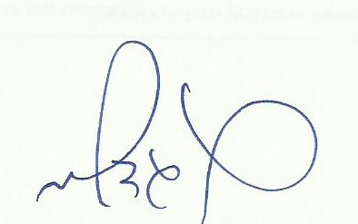
Name Name Keren Gdalyhau Malki (Company manager) Name Marijcke Voorsluijs
Date Date February 16, 2015 Date 12 februari 2015
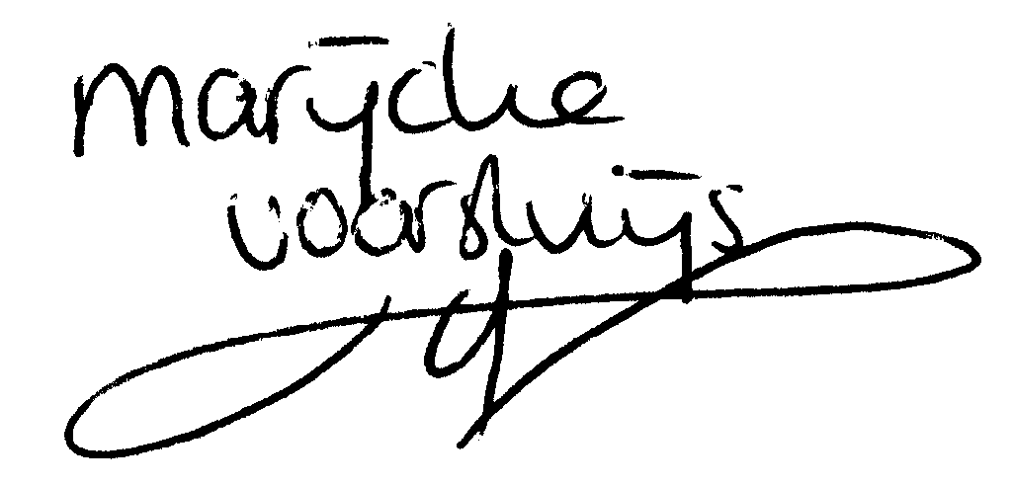
Signature Signature Signature

© Marijcke Voorsluijs for Van Baasbank & Baggerman (Thanks to Stadsschouwburg Utrecht and Het Muziektheater), June 2002
Reproduction and use of this document is authorized, provided the source is acknowledged and the writer informed
Comments are always greatly appreciated! Please send an e-mail to marijcke@totheater.nl

