PART I DATA

1 The Production

Company TRUE
Show TRUE
Director Takayuki Fujimoto
Set designer Takayuki Fujimoto
Lighting designer Takayuki Fujimoto

Sound designer DaitoManabe & Takuya Minami
Costume designer Noriko Kitamura
Producer Van Baasbank & Baggerman
Date
Theatre

2 The Theatre

Name of the theatre
Address
Postal code & city
General phone number
General fax number
General e-mail address
Technical phone number

Technical fax number
Technical e-mail address

Contacts:
General management
Technical management
General RAI responsible
RAI responsible on stage

3 The Company

Name of the company TRUE
Address #408 61-1 Okazaki Tenno-cho,
Postal code & city Sakyo-ku 606-8335 Kyoto
Country of residence Japan
General phone number +81 75 752 2351
General fax number +81 75 752 2351
General e-mail address info@true.gr.jp
Technical phone number +81 75 752 2351
Technical fax number +81 75 752 2351
technical e-mail address kinsei@dumbtype.com
Mobile phone on tour +81 90 9114 3560
Contacts:
General management Takayuki Fujimoto
Technical management Takayuki Fujimoto
Production management TAKAGI Koichiro
Stage manager on tour So Ozaki
Rigging engineer on tour So Ozaki
Lighting engineer on tour Takayuki Fujimoto
Sound engineer on tour Yoshihisa Fukuhara
General RAI responsible Takayuki Fujimoto
RAI responsible on tour Takayuki Fujimoto

4 The Producer

Name of the producer Van Baasbank & Baggerman
Address Keizersgracht 258
Postal code & city 1016 EV Amsterdam
General phone number 020-6242631
General fax number 020-6227850
General e-mail address info@baasbank-baggerman.nl
Technical phone number 06-50267679
Technical fax number 020-6227850
Technical e-mail address marijcke@baasbank-baggerman.nl
Contacts:
General management Jaap van Baasbank
Production management JG Baggerman
Technical management Marijcke Voorsluijs
Stage manager on tour Dennis Wevers
General RAI responsible Marijcke Voorsluijs
RAI responsible on tour Dennis Wevers

PART II RESPONSIBILITIES

1 The Theatre
- Knowledge of risk assessment and safety regulations, shown in a general Risk Assessment Inventory (in Dutch: RI&E).
- Practise of this knowledge at the workplace.
- Responsible behaviour of technicians employed or hired by the theatre.
- Safety education of technicians employed or hired by the theatre.
- Appropriate personal protective equipment for technicians employed by the theatre.
- Safety on stage in general.
- Safety, certification and maintenance of house materials and utensils.
- Safe operation of the theatre's installations.
- Safety of materials rented by the theatre.
- Contact with local fire department to obtain permits for fire effects, based on information provided by the company through the producer.
- Working schedule for technicians employed or hired by the theatre, based on agreements between company and theatre, in accordance with the Dutch working hours regulations.

2 The Company
- Knowledge of risk assessment and safety regulations valid in the Netherlands.
- Practise of this knowledge at the workplace.
- Responsible behaviour of technicians employed or hired by the company.
- Safety education of technicians employed or hired by the company.
- Correct, appropriate and complete information about the safety aspects of the production for the producer and the theatre.
- Appropriate safety instructions for house technicians about the company's materials, during setup, rehearsal, show and strike
- Appropriate personal protective equipment for company technicians, and for house technicians if necessary for handling company materials or installations.
- Safety, certification and maintenance of all company materials and utensils used on tour.
- Safe operation of company installations.
- Safety of materials rented by the company.
- Working schedule for technicians employed or hired by the company in accordance with the Dutch working hours regulations.

3 The Producer
- Knowledge of risk assessment and safety regulations valid in the Netherlands.
- Practise of this knowledge at the workplace.
- Correct, appropriate and complete information about the standards, rules and regulations in the Netherlands.
- Correct, appropriate and complete information about the safety aspects of the production to the theatre, based on information provided by the company.
- Work permits for company members.
- Adequate tour planning as to enable the company to schedule its members in accordance with the Dutch working hours regulations.
- Responsible behaviour of technicians employed or hired by the producer.
- Safety education of technicians employed or hired by the producer.
- Appropriate personal protective equipment for technicians employed by the producer.
- Safety of materials owned or rented by the producer.
- Working schedule for technicians employed or hired by the producer in accordance with the Dutch working hours regulations.

PART III CHECKLIST
Is safety for the technicians being monitored with relation to:
- hazardous surfaces (sharp edges, corners, points, rough surfaces, protruding parts)? scaff setup is directed by a Layher specialist
- movements of parts or material which may result in a person being hit? scaff setup is directed by a Layher specialist
- trapping, tripping, falling and slipping? scaff setup in work lights
- unhealthy low or high temperatures? indoor performance
- blinding or electrocution of persons? no such material
- sound levels high enough to damage hearing (see manual ch. 10 about sound)?
- fire or explosion? no such material
Is personal protective equipment being provided and used? technicians wear safety shoes
Is safety for the artists being taken into account with relation to:
- hazardous surfaces (sharp edges, corners, points, rough surfaces, protruding parts)? artists are trained to climb the scaff sets
Is safety for the audience being taken into account with relation to:
- trapping, tripping, falling and slipping? no objects installed in audience area
Is safety information being given to the audience about specific risks or hazards? no specific risks for the audience
Is working at heights avoided during setup and strike? hanging of lights
Is working at heights avoided during rehearsal and show? artists climb the scaff sets
Is a safe way to reach the working height being guaranteed? ladder inside scaffold
Is (personal) protection being provided and used? hand rails on all levels
Are the persons who work at heights qualified to do so? (specify qualification) theatre technicians / trained artists
Are the necessary certificates being carried?
Has the set been constructed by qualified persons? (specify in last column) So Ozaki, Layher
Is the set made of flame resistant material, or treated with flame retarder? screen is fire resistant
Are certificates being carried?
Has the use of electricity on the set been avoided?
Are regular checks performed on the electrical parts?
Is an earth line being attached to metal parts on which electricity is used?
Has the use of heavy materials been avoided? (specify weight of heaviest parts in last column) 120kg
Do the parts have their weight indicated on them?
Has overhead rigging of the set been avoided? only a truss with lights
Has overhead rigging of heavy weights been avoided? (weight of heaviest points in last column) 120kg total weight
Are safety regulations being respected when doing overhead rigging? certified rigging materials
Has the Working Load Limit of all materials been taken into account?
Are the necessary certificates being carried?
Are the persons who do the overhead rigging qualified to do so? (specify qualification) experienced theatre rigger
Have fly movements of the set been avoided?
Are the props made of flame retardant material, or treated with flame retarder?
Has protection of the artists been taken into account in the choice or construction of the props?
Are the costumes flame resistant, or treated with flame retarder? (Only in case of open fire.) no open flame
Has the use of smoke been avoided? 1 cigarette is smoked on stage

PART IV SIGNATURES
The theatre declares
- to accept the responsibilities described in part II of this document
- to have read and accepted the information given in part I and III

The company declares
- to accept the responsibilities described in part II of this document
- to have given complete and correct information in part I and III is
- that the information is given by persons with ample knowledge of safety and risk assessment at the workplace.

The producer declares
- to accept the responsibilities described in part II of this document
- to have read and accepted the information given in part I and III

The theatre The company The producer
Name Name Takayuki Fujimoto Name Marijcke Voorsluijs
Date Date Date 18 september 2009
Signature Signature Signature
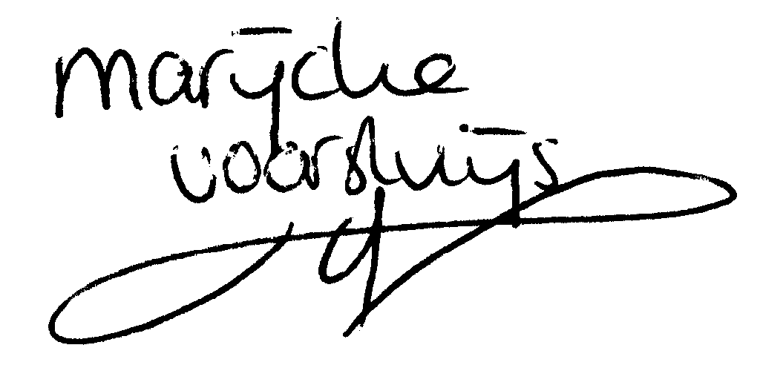
© Marijcke Voorsluijs for Van Baasbank & Baggerman (Thanks to Stadsschouwburg Utrecht and Het Muziektheater), June 2002
Reproduction and use of this document is authorized, provided the source is acknowledged and the writer informed
Comments are always greatly appreciated! Please send an e-mail to marijcke@totheater.nl

