PART I DATA

1 The Production

Company Les Ballets Trockadero de Monte Carlo
Show Mixed Repertoire
Director Tory Dobrin
Set designer Jason Courson
Lighting designer Kip Marsh / Emily McGillicuddy
Sound designer
Costume designer
Producer GPAG
Date
Theatre

2 The Theatre

Name of the theatre
Address
Postal code & city
General phone number
General e-mail address
Technical phone number
Technical fax number
Technical e-mail address
Contacts:
General management
Technical management
General RAI responsible
RAI responsible on stage

3 The Company

Name of the company Les Ballets Trockadero de Monte Carlo
Address 152 W ⁵⁷th Street, ⁵th Floor
Postal code & city New York 10019
Country of residence USA
General phone number +1 646 456 3774
General e-mail address lesballets@aol.com
Technical phone number +1 347 385 1160
Technical e-mail address martinezriveraisabel@gmail.com
Mobile phone on tour +1 347 385 1160

Contacts:
General management Tory Dobrin / Barbara Domue
Technical management Isabel Martinez-Rivera
Production management Isabel Martinez-Rivera
Stage manager on tour Barbara Domue
Rigging engineer on tour Isabel Martinez-Rivera
Lighting engineer on tour Emily McGillicuddy
Sound engineer on tour N/A
General RAI responsible Isabel Martinez-Rivera
RAI responsible on tour Isabel Martinez-Rivera

4 The Producer

Name of the producer GPAG (Global Performing Arts Group)
Address Funenpark 599
Postal code & city 1018 AK Amsterdam
General phone number +31 (0)20 679 1994
General e-mail address info@gpag.nl
Technical phone number +31-650267679
Technical e-mail address marijcke@totheater.nl
Contacts:
General management JG Baggerman
Production management JG Baggerman
Technical management Marijcke Voorsluijs
Stage manager on tour Kees Knegjes
General RAI responsible Marijcke Voorsluijs
RAI responsible on tour Kees Knegjes

PART II RESPONSIBILITIES

1 The Theatre
- Knowledge of risk assessment and safety regulations, shown in a general Risk Assessment Inventory (in Dutch: RI&E).
- Practise of this knowledge at the workplace.
- Responsible behaviour of technicians employed or hired by the theatre.
- Safety education of technicians employed or hired by the theatre.
- Appropriate personal protective equipment for technicians employed by the theatre.
- Safety on stage in general.
- Safety, certification and maintenance of house materials and utensils.
- Safe operation of the theatre's installations.
- Safety of materials rented by the theatre.
- Contact with local fire department to obtain permits for fire effects, based on information provided by the company through the producer.
- Working schedule for technicians employed or hired by the theatre, based on agreements between company and theatre, in accordance with the Dutch working hours regulations.

2 The Company
- Knowledge of risk assessment and safety regulations valid in the Netherlands.
- Practise of this knowledge at the workplace.
- Responsible behaviour of technicians employed or hired by the company.
- Safety education of technicians employed or hired by the company.
- Correct, appropriate and complete information about the safety aspects of the production for the producer and the theatre.
- Appropriate safety instructions for house technicians about the company's materials, during setup, rehearsal, show and strike
- Appropriate personal protective equipment for company technicians, and for house technicians if necessary for handling company materials or installations.
- Safety, certification and maintenance of all company materials and utensils used on tour.
- Safe operation of company installations.
- Safety of materials rented by the company.
- Working schedule for technicians employed or hired by the company in accordance with the Dutch working hours regulations.

3 The Producer
- Knowledge of risk assessment and safety regulations valid in the Netherlands.
- Practise of this knowledge at the workplace.
- Correct, appropriate and complete information about the standards, rules and regulations in the Netherlands.
- Correct, appropriate and complete information about the safety aspects of the production to the theatre, based on information provided by the company.
- Work permits for company members.
- Adequate tour planning as to enable the company to schedule its members in accordance with the Dutch working hours regulations.
- Responsible behaviour of technicians employed or hired by the producer.
- Safety education of technicians employed or hired by the producer.
- Appropriate personal protective equipment for technicians employed by the producer.
- Safety of materials owned or rented by the producer.
- Working schedule for technicians employed or hired by the producer in accordance with the Dutch working hours regulations.

PART III CHECKLIST

Has a person been designated to be responsible for safety on stage from setup till strike?
Are safety instructions being provided to all participants?
Does the company carry an appropriate First Aid Kit for those who work on stage?
Is safety for the technicians being monitored with relation to:
- trapping, tripping, falling and slipping? cables are taped
- unhealthy low or high temperatures? indoor performances
- blinding or electrocution of persons? no such material
- sound levels high enough to damage hearing (see manual ch. 10 about sound)? no high sound levels
- fire or explosion? no such material
Are regular checks performed on the materials?
Are safety documents and instructions being carried?
Is personal protective equipment being provided and used? technicians wear safety shoes
Does the company guarantee not to block the theatre's emergency exits and exit signs?
Does the company guarantee not to block the way to the theatre's fire extinguishing materials?
Does the company carry an appropriate First Aid Kit for those who work on the show?
Is safety for the artists being taken into account with relation to:
- hazardous surfaces (sharp edges, corners, points, rough surfaces, protruding parts)? covered or removed as needed
- movements of parts or material which may result in a person being hit? appropriately marked
- trapping, tripping, falling and slipping? cables are taped, backstage area is lit
- unhealthy low or high temperatures? indoor performances
- blinding or electrocution of persons? no such material
- sound levels high enough to damage hearing? no high sound levels
- fire or explosion? no such materials
Is safety for the audience being taken into account with relation to:
- movements of parts or material which may result in a person being hit? no objects placed in auditorium
Is safety information being given to the audience about specific risks or hazards? no specific risks for the audience
Is working at heights avoided during setup and strike? focusing lights with the telescope/genie from the theatre
Are the persons who work at heights qualified to do so? (specify qualification) venue lighting technicians
Has the set been constructed by qualified persons? (specify in last column) only backdrops
Is the set made of flame resistant material, or treated with flame retarder? flameproof certificates available upon request
Are the persons who do the overhead rigging qualified to do so? (specify qualification) venue technical staff operates fly system
Have fly movements of the set been avoided? All drops moving at intermission or behind the main curtain.
Have safety measures been taken to protect persons during fly movements of the set? dancers know the cues, company stage manager check that stage is clear during movements
Are the props made of flame retardant material, or treated with flame retarder?
Has the use of weapons been avoided?
Is the safety of orchestra members in the pit being taken into account? we don't use the orchestra pit
Are the costumes flame resistant, or treated with flame retarder? (Only in case of open fire.) no open flame
Has attention been paid to the comfort of the persons who handle and wear the costumes?
Does lighting equipment brought by the company meet international safety standards? no such equipment
Does rental lighting equipment come from a professional company? (specify in last column) Ampco Flashlight
Does sound equipment brought by the company meet international safety standards? no such equipment
Does rental sound equipment come from a professional company? (specify in last column) no such equipment
Has the use of smoke been avoided? rented smoke machine

PART IV SIGNATURES
The theatre declares
- to accept the responsibilities described in part II of this document
- to have read and accepted the information given in part I and III

The company declares
- to accept the responsibilities described in part II of this document
- to have given complete and correct information in part I and III is
- that the information is given by persons with ample knowledge of safety and risk assessment at the workplace.

The producer declares
- to accept the responsibilities described in part II of this document
- to have read and accepted the information given in part I and III

The theatre The company The producer
Name Name Isabel Martinez-Rivera Name Marijcke Voorsluijs
Date Date 14 augustus 2014 Date 14 augustus 2014
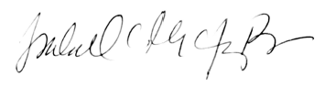
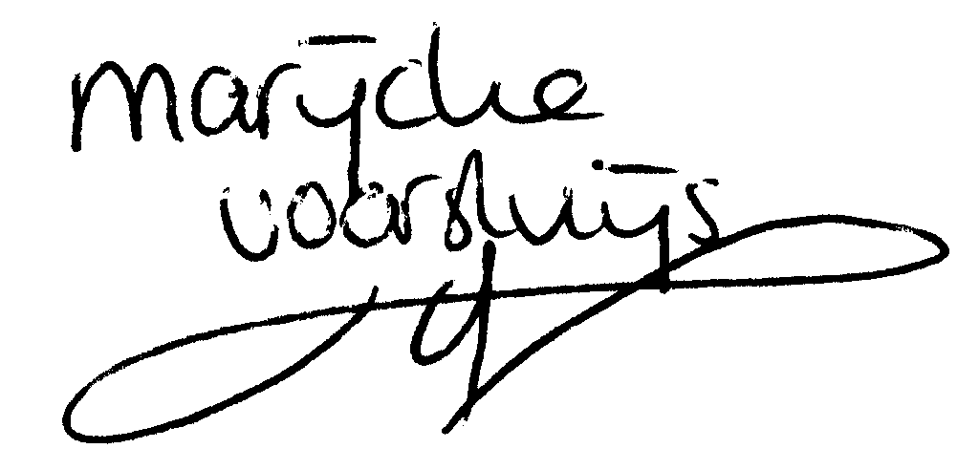
Signature Signature Signature

© Marijcke Voorsluijs for Van Baasbank & Baggerman (Thanks to Stadsschouwburg Utrecht and Het Muziektheater), June 2002
Reproduction and use of this document is authorized, provided the source is acknowledged and the writer informed
Comments are always greatly appreciated! Please send an e-mail to marijcke@totheater.nl

