PART I DATA

1 The Production

Company Hotel Pro Forma
Show War Sum Up
Director Kirsten Dehlholm
Set designer Kirsten Dehlholm, Willie Flindt
Lighting designer Jesper Kongshaug

Sound designer Andris Uze
Costume designer Henrik Vibskov
Producer Van Baasbank & Co
Date
Theatre

2 The Theatre

Name of the theatre
Address
Postal code & city
General phone number
General fax number
General e-mail address
Technical phone number

Technical fax number
Technical e-mail address

Contacts:
General management
Technical management
General RAI responsible
RAI responsible on stage

3 The Company

Name of the company Hotel Pro Forma
Address Strandlodsvej 6
Postal code & city DK - 2300 København S
Country of residence Denmark
General phone number +45 3254 0217
General fax number +45 3296 9686
General e-mail address mail@hotelproforma.dk
Technical phone number +45 32 64 01 33
Technical fax number
technical e-mail address platais@gmail.com
Mobile phone on tour +371 29 433 117
Contacts:
General management Bradley Allen
Technical management Oskars Plataiskalns
Production management Bradley Allen
Stage manager on tour Lauris Bimbers
Rigging engineer on tour Oskars Plataiskalns
Lighting engineer on tour Oskars Plataiskalns
Sound engineer on tour Andris Uze
General RAI responsible Oskars Plataiskalns
RAI responsible on tour Oskars Plataiskalns

4 The Producer

Name of the producer Van Baasbank & Co
Address Keizersgracht 258
Postal code & city 1016 EV Amsterdam
General phone number 020-6242631
General fax number 020-6227850
General e-mail address info@baasbank-co.nl
Technical phone number 06-50267679
Technical fax number 020-6227850
Technical e-mail address marijcke@baasbank-co.nl
Contacts:
General management Jaap van Baasbank
Production management Dick Vos
Technical management Marijcke Voorsluijs
Stage manager on tour Kees Knegjes
General RAI responsible Marijcke Voorsluijs
RAI responsible on tour Kees Knegjes

PART II RESPONSIBILITIES

1 The Theatre
- Knowledge of risk assessment and safety regulations, shown in a general Risk Assessment Inventory (in Dutch: RI&E).
- Practise of this knowledge at the workplace.
- Responsible behaviour of technicians employed or hired by the theatre.
- Safety education of technicians employed or hired by the theatre.
- Appropriate personal protective equipment for technicians employed by the theatre.
- Safety on stage in general.
- Safety, certification and maintenance of house materials and utensils.
- Safe operation of the theatre's installations.
- Safety of materials rented by the theatre.
- Contact with local fire department to obtain permits for fire effects, based on information provided by the company through the producer.
- Working schedule for technicians employed or hired by the theatre, based on agreements between company and theatre, in accordance with the Dutch working hours regulations.

2 The Company
- Knowledge of risk assessment and safety regulations valid in the Netherlands.
- Practise of this knowledge at the workplace.
- Responsible behaviour of technicians employed or hired by the company.
- Safety education of technicians employed or hired by the company.
- Correct, appropriate and complete information about the safety aspects of the production for the producer and the theatre.
- Appropriate safety instructions for house technicians about the company's materials, during setup, rehearsal, show and strike
- Appropriate personal protective equipment for company technicians, and for house technicians if necessary for handling company materials or installations.
- Safety, certification and maintenance of all company materials and utensils used on tour.
- Safe operation of company installations.
- Safety of materials rented by the company.
- Working schedule for technicians employed or hired by the company in accordance with the Dutch working hours regulations.

3 The Producer
- Knowledge of risk assessment and safety regulations valid in the Netherlands.
- Practise of this knowledge at the workplace.
- Correct, appropriate and complete information about the standards, rules and regulations in the Netherlands.
- Correct, appropriate and complete information about the safety aspects of the production to the theatre, based on information provided by the company.
- Work permits for company members.
- Adequate tour planning as to enable the company to schedule its members in accordance with the Dutch working hours regulations.
- Responsible behaviour of technicians employed or hired by the producer.
- Safety education of technicians employed or hired by the producer.
- Appropriate personal protective equipment for technicians employed by the producer.
- Safety of materials owned or rented by the producer.
- Working schedule for technicians employed or hired by the producer in accordance with the Dutch working hours regulations.

PART III CHECKLIST
Is safety for the technicians being monitored with relation to:
- unhealthy low or high temperatures? indoor performance
- fire or explosion? no such material
Is personal protective equipment being provided and used? technicians wear safety shoes
Is safety for the artists being taken into account with relation to:
- hazardous surfaces (sharp edges, corners, points, rough surfaces, protruding parts)? entrances are well lit
- movements of parts or material which may result in a person being hit? no movements
- trapping, tripping, falling and slipping? cables are taped
- blinding or electrocution of persons? no such material
Is safety for the audience being taken into account with relation to:
- movements of parts or material which may result in a person being hit? no such material
- trapping, tripping, falling and slipping? no objects installed in audience area
Is safety information being given to the audience about specific risks or hazards? no specific risks for the audience
Is working at heights avoided during setup and strike? hanging of lights, building of set
Is working at heights avoided during rehearsal and show? choir members move on the scaffolding
Is a safe way to reach the working height being guaranteed? stairs
Is (personal) protection being provided and used? safety rails are installed
Are the persons who work at heights qualified to do so? (specify qualification) experienced theatre technicians, artists who are used to the set
Are the necessary certificates being carried?
Is the set made of flame resistant material, or treated with flame retarder?
Are certificates being carried?
Has the use of electricity on the set been avoided? lights are attached to the set
Are regular checks performed on the electrical parts?
Is an earth line being attached to metal parts on which electricity is used? there is earth on each lighting device
Has the use of heavy materials been avoided? (specify weight of heaviest parts in last column) 90 kg
Do the parts have their weight indicated on them?
Is the safety of orchestra members in the pit being taken into account? only the conductor is in the pit
Does the company guarantee not to block the emergency exits and exit signs around the pit?
Are measures being taken to protect persons from falling into the orchestra pit? LED line between stage and orchestra pit
Are the costumes flame resistant, or treated with flame retarder? (Only in case of open fire.) no open flame
Does rental lighting equipment come from a professional company? (specify in last column) www.na.lv
Does rental sound equipment come from a professional company? (specify in last column) no sound rentals

PART IV SIGNATURES
The theatre declares
- to accept the responsibilities described in part II of this document
- to have read and accepted the information given in part I and III

The company declares
- to accept the responsibilities described in part II of this document
- to have given complete and correct information in part I and III is
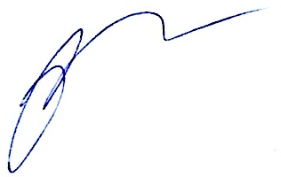
- that the information is given by persons with ample knowledge of safety and risk assessment at the workplace.

The producer declares
- to accept the responsibilities described in part II of this document
- to have read and accepted the information given in part I and III

The theatre The company The producer
Name Name Oskars Plataiskalns Name Marijcke Voorsluijs
Date Date 20 februari 2014 Date 18 februari 2014
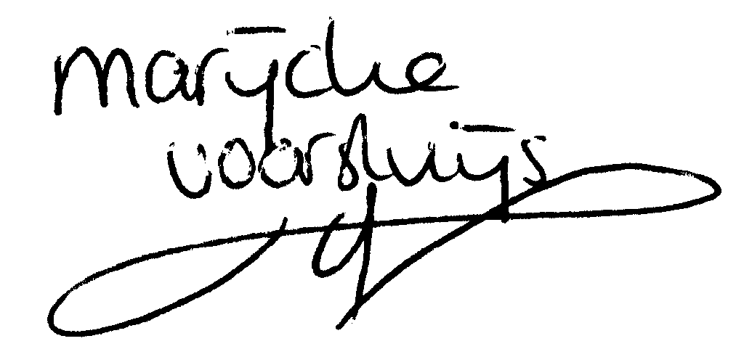
Signature Signature Signature

© Marijcke Voorsluijs for Van Baasbank & Baggerman (Thanks to Stadsschouwburg Utrecht and Het Muziektheater), June 2002
Reproduction and use of this document is authorized, provided the source is acknowledged and the writer informed
Comments are always greatly appreciated! Please send an e-mail to marijcke@totheater.nl

