PART I DATA

1 The Production

Company Ultima Vez
Show nieuwZwart
Director Wim Vandekeybus
Set designer Wim Vandekeybus
Lighting designer Alban Rouge, Wim Vandekeybus

Sound designer Benjamin Dandoy
Costume designer Lieve Meeussen, Heidi Ehrhart
Producer Van Baasbank & Baggerman
Date
Theatre

2 The Theatre

Name of the theatre
Address
Postal code & city
General phone number
General fax number
General e-mail address
Technical phone number

Technical fax number
Technical e-mail address

Contacts:
General management
Technical management
General RAI responsible
RAI responsible on stage

3 The Company

Name of the company Ultima Vez
Address Koolmijnenkaai 34
Postal code & city 1080 Brussels
Country of residence Belgium
General phone number +32 2 219 55 28
General fax number +32 2 219 68 02
General e-mail address info@ultimavez.com
Technical phone number +32 475713650
Technical fax number +32 2 219 68 02
technical e-mail address ralfnonn@skynet.be
Mobile phone on tour +32 475713650
Contacts:
General management Kristien De Coster
Technical management Ralf Nonn
Production management Rebecca De Backer
Stage manager on tour Ralf Nonn
Rigging engineer on tour Ralf Nonn
Lighting engineer on tour Alban Rouge
Sound engineer on tour Benjamin Dandoy
General RAI responsible Ralf Nonn
RAI responsible on tour Ralf Nonn

4 The Producer

Name of the producer Van Baasbank & Baggerman
Address Keizersgracht 258
Postal code & city 1016 EV Amsterdam
General phone number 020-6242631
General fax number 020-6227850
General e-mail address info@baasbank-baggerman.nl
Technical phone number 06-50267679
Technical fax number 020-6227850
Technical e-mail address marijcke@baasbank-baggerman.nl
Contacts:
General management Jaap van Baasbank
Production management JG Baggerman
Technical management Marijcke Voorsluijs
Stage manager on tour N/A
General RAI responsible Marijcke Voorsluijs
RAI responsible on tour N/A

PART II RESPONSIBILITIES

1 The Theatre
- Knowledge of risk assessment and safety regulations, shown in a general Risk Assessment Inventory (in Dutch: RI&E).
- Practise of this knowledge at the workplace.
- Responsible behaviour of technicians employed or hired by the theatre.
- Safety education of technicians employed or hired by the theatre.
- Appropriate personal protective equipment for technicians employed by the theatre.
- Safety on stage in general.
- Safety, certification and maintenance of house materials and utensils.
- Safe operation of the theatre's installations.
- Safety of materials rented by the theatre.
- Contact with local fire department to obtain permits for fire effects, based on information provided by the company through the producer.
- Working schedule for technicians employed or hired by the theatre, based on agreements between company and theatre, in accordance with the Dutch working hours regulations.

2 The Company
- Knowledge of risk assessment and safety regulations valid in the Netherlands.
- Practise of this knowledge at the workplace.
- Responsible behaviour of technicians employed or hired by the company.
- Safety education of technicians employed or hired by the company.
- Correct, appropriate and complete information about the safety aspects of the production for the producer and the theatre.
- Appropriate safety instructions for house technicians about the company's materials, during setup, rehearsal, show and strike
- Appropriate personal protective equipment for company technicians, and for house technicians if necessary for handling company materials or installations.
- Safety, certification and maintenance of all company materials and utensils used on tour.
- Safe operation of company installations.
- Safety of materials rented by the company.
- Working schedule for technicians employed or hired by the company in accordance with the Dutch working hours regulations.

3 The Producer
- Knowledge of risk assessment and safety regulations valid in the Netherlands.
- Practise of this knowledge at the workplace.
- Correct, appropriate and complete information about the standards, rules and regulations in the Netherlands.
- Correct, appropriate and complete information about the safety aspects of the production to the theatre, based on information provided by the company.
- Work permits for company members.
- Adequate tour planning as to enable the company to schedule its members in accordance with the Dutch working hours regulations.
- Responsible behaviour of technicians employed or hired by the producer.
- Safety education of technicians employed or hired by the producer.
- Appropriate personal protective equipment for technicians employed by the producer.
- Safety of materials owned or rented by the producer.
- Working schedule for technicians employed or hired by the producer in accordance with the Dutch working hours regulations.

PART III CHECKLIST
Is safety for the technicians being monitored with relation to:
- movements of parts or material which may result in a person being hit? special care when rigging platform
- trapping, tripping, falling and slipping? work lights during setup
- unhealthy low or high temperatures? indoor performance
- blinding or electrocution of persons? no such material
- fire or explosion? no such material
Is personal protective equipment being provided and used? technicians wear safety shoes
Is safety for the artists being taken into account with relation to:
- movements of parts or material which may result in a person being hit? dancers trained with the set extensively
- trapping, tripping, falling and slipping? lighting cables are taped
Is safety for the audience being taken into account with relation to:
- trapping, tripping, falling and slipping? no objects installed in audience area
Is safety information being given to the audience about specific risks or hazards? no specific risks for the audience
Is working at heights avoided during setup and strike? hanging of lights, rigging of wires
Is working at heights avoided during rehearsal and show? 1 dancer climbs on the truss with the panels, once she climbs up and down without extra safety, the second time wearing a harness secured with a cable to jump off and swing over the stage; musicians climb on their platform with a ladder, sit down and stay there during the show
Is a safe way to reach the working height being guaranteed? dancers are trained to climb, and a run is done on the show day
Is (personal) protection being provided and used? the theatre is to provide safe access to, and working conditions on the grid for fixing the rigging points
Are the persons who work at heights qualified to do so? (specify qualification) theatre technicians, trained dancers
Are the necessary certificates being carried? certificates present for all company materials
Is the set made of flame resistant material, or treated with flame retarder? foil is fire resistant
Are certificates being carried?
Has the use of electricity on the set been avoided? several lamps are manipulated by the dancers
Has the use of heavy materials been avoided? (specify weight of heaviest parts in last column) platform: 8 points of 250 kg
Do the parts have their weight indicated on them? company crew gives instructions
Has overhead rigging of the set been avoided? platform, wires and ladder
Has overhead rigging of heavy weights been avoided? (weight of heaviest points in last column) platform
Are safety regulations being respected when doing overhead rigging? certified materials
Has the Working Load Limit of all materials been taken into account?
Are the necessary certificates being carried?
Are the persons who do the overhead rigging qualified to do so? (specify qualification) experienced theatre rigger
Have fly movements of the set been avoided? manually operated, pulley system
Have safety measures been taken to protect persons during fly movements of the set? dancers manipulate the movements
Does rental lighting equipment come from a professional company? (specify in last column) Flashlight
Does rental sound equipment come from a professional company? (specify in last column) no such material

PART IV SIGNATURES
The theatre declares
- to accept the responsibilities described in part II of this document
- to have read and accepted the information given in part I and III

The company declares
- to accept the responsibilities described in part II of this document
- to have given complete and correct information in part I and III is
- that the information is given by persons with ample knowledge of safety and risk assessment at the workplace.

The producer declares
- to accept the responsibilities described in part II of this document
- to have read and accepted the information given in part I and III

The theatre The company The producer
Name Name Ralf Nonn Name Marijcke Voorsluijs
Date Date Date 7 december 2009
Signature Signature Signature
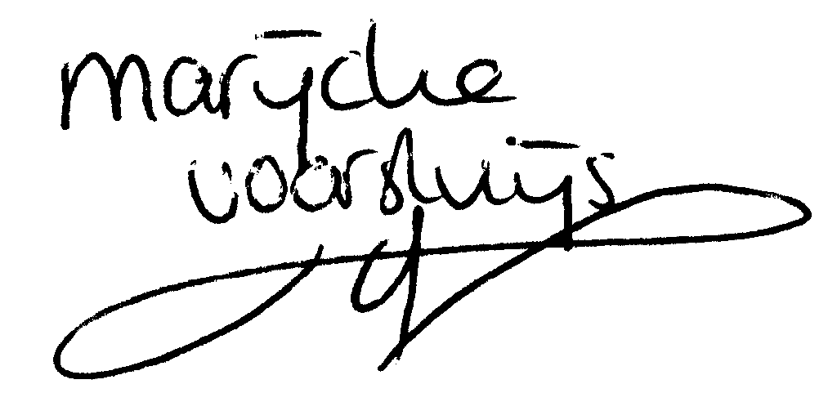
© Marijcke Voorsluijs for Van Baasbank & Baggerman (Thanks to Stadsschouwburg Utrecht and Het Muziektheater), June 2002
Reproduction and use of this document is authorized, provided the source is acknowledged and the writer informed
Comments are always greatly appreciated! Please send an e-mail to marijcke@totheater.nl

